IMAT3451 Final Year Project Periodic Progress Report (PPR)

Programme/Course Title: Computer games programming

Name: Connor Rowland Assessment Period: week 25

Project Title: Dobble Report Number: 9

Objectives for Period: (refer to previous report)
Refactor to a final finished product.

Summary of Progress for Period: (identify evidence of progress)
All work complete.

Problem Areas and Suggested Solutions:

Objectives, Deliverables & Plan for Next Period:
Write report

Date of Next Review: N/A

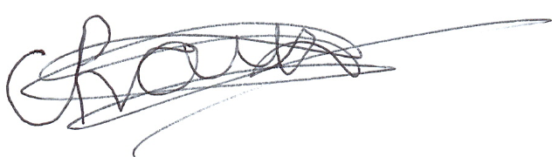
Student’s Signature: Date: 21/03/2019
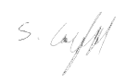

Supervisor’s Signature: Date: 21/03/2019

Comments (if any):

